Experiment No. 2: LED Control Using Arduino

## Aim

To write code to control an LED using an Arduino.

## Theory

An LED (Light Emitting Diode) is a semiconductor device that emits light when electric current passes through it. It is commonly used for indicators and visual feedback in electronic devices.

Arduino is an open-source microcontroller platform capable of controlling digital output devices like LEDs.

## Materials Required

- Arduino Uno board  
- LED  
- 220-ohm resistor  
- Breadboard  
- Jumper wires

## Procedure

1. Place the LED on the breadboard.  
2. Connect the anode (long leg) to pin 9 on Arduino through a 220-ohm resistor.  
3. Connect the cathode (short leg) to GND on the Arduino.

## Code

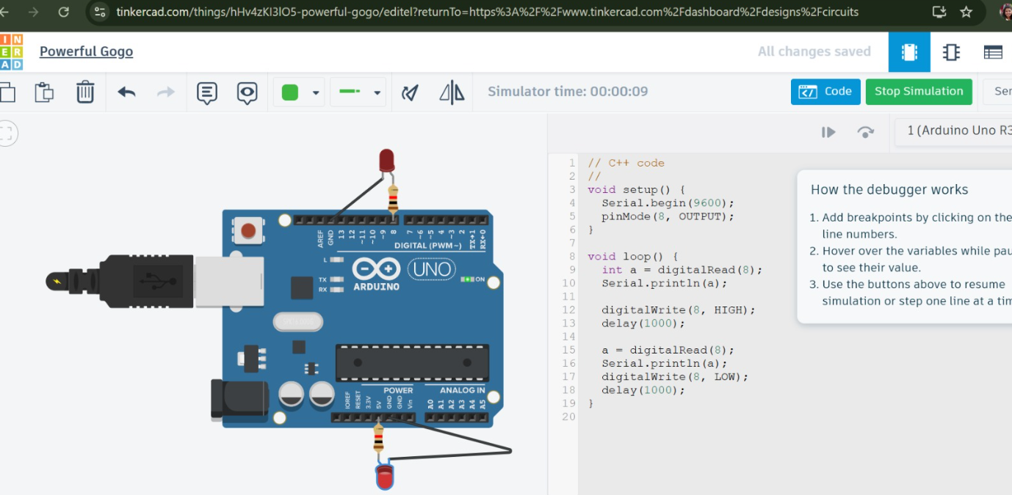

## Working

The LED connected to pin 9 blinks every second, demonstrating digital output control using Arduino.

## Conclusion

The LED control experiment taught how to connect and program a basic digital output component using Arduino.